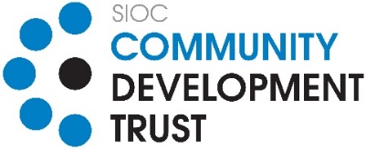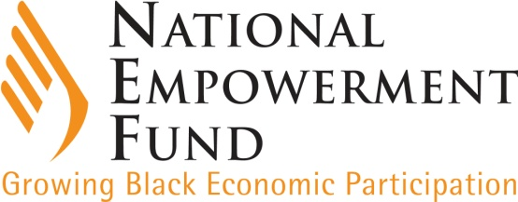

MEDIA STATEMENT FOR ALL NEWS DESKS

Slug: (SIOC-CDT and NEF Partnership) 14 September 2020
________________________________________________________________

SIOC Community Development Trust partners with The National Empowerment Fund on a R16.1 million Fund

Developing local SMMEs is at the heart of SIOC-CDT and as such the Trust has partnered with The National Empowerment Fund (NEF), an agency of the dtic whose mandate is to grow black economic participation, to provide financial and non-financial support to SMMEs in Limpopo and the Northern Cape that have been affected by the COVID-19 pandemic. The partnership amounts to R16.1 million and is for the benefit of SMMEs owned and managed by black South African citizens.

Stretching across South Africa’s borders, the Northern Cape and Limpopo Provinces are filled with endless natural, commercial and human potential. However, these provinces remain undeveloped and record some of the highest unemployment and poverty rates in the country. Mining and agriculture are the long-standing pillars of economic activity in these regions, but these have been diminished by falling commodity prices, drought and slow regional and national economic growth.

This joint fund aims to support black-owned SMMEs that were operational at least 6 months before the COVID-19 pandemic began in March 2020. The partnership will see the NEF co-managing the two funds that have been established as a result of the partnership.

SIOC-CDT/NEF COVID-19 Grant Fund
R3.5 million of the total fund will go towards grant funding targeted at formal and informal SMMEs residing within the qualifying areas of Thabazimbi in the Limpopo Province and Tsantsabane, Gamagara, Gasegonyana and Joe Morolong in the Northern Cape, to benefit businesses that have been severely affected by the COVID-19 pandemic. The grant amount is limited to a minimum of R10 000 (ten thousand Rand) to informal traders and a maximum of R100 000 (one hundred thousand Rand) to formal businesses per transaction.

Grant funding will be approved by the Regional Project Steering Committee selected by both institutions, while the hybrid fund will be administered by the NEF’s Investment Committees. Furthermore, the NEF will be responsible for the disbursement of both funds.

SIOC-CDT/NEF Covid-19 Hybrid Grant Fund
R12.625 million of the total fund will be set aside for the Hybrid Fund where the applicant will be supported through a mixture of loan and grant funding, to the extent that the loan will represent 60% of the funding required and 40% will be the grant portion. This fund will also be targeted strictly at the qualifying areas within Thabazimbi in the Limpopo Province and Tsantsabane, Gamagara, Gasegonyana and Joe Morolong in the Northern Cape area. Transactions with a minimum funding requirement of R250 000 and a maximum of R600 000will be considered. The NEF Investment Committee will be responsible for all investment decisions aligned with SIOC-CDT standards, and in accordance with existing NEF Corporate Governance structures.

“The COVID-19 pandemic has had a devastating impact on our beneficiary communities and we are optimistic that this partnership will go a long way in supporting entrepreneurship and innovative new businesses ideas while scaling up existing ones”, Enterprise development is at the heart of SIOC-CDT and as such, we plan to drive entrepreneurship empowerment for local entrepreneurs through this dynamic partnership by ensuring that they are commercially viable”, says the CEO of the SIOC Community Development Trust, Mr Vusani Malie.

SIOC-CDT was formed in 2006 to be the custodian of Trust income meant for improving the local SIOC (Pty) Ltd mining operations’ beneficiary communities. These benefits are targeted to be long-term, to ensure communities continue realising the rewards beyond the operations of the mine.

“The NEF has since inception approved in excess of 1058 transactions worth more than R10.6 billion across the country. As a partner trusted by many, investors and investees alike, the NEF has secured clean external audit opinions for 17 years running, and this attests to our commitment to good corporate governance and international best practise. This we do because the standards that we set for the NEF are the same that we hold our investees to,” says the CEO of the NEF, Ms Philisiwe Mthethwa.

For media enquiries
Moemise Motsepe  Head: Marketing & Communications  083 533 4114 / motsepem@nefcorp.co.za | Refilwe Sebogodi  Head: Stakeholder Relations and Communications  082 901 8364 / Refiwe@sioc-cdt.com

